Guangzhou HC Information Technology Co., Ltd.

www.wavesen.com

Phone: 020-84083341 Fax: 020-84332079 QQ:1043073574

Address: Room 527, No.13, Jiangong Road, Tianhe soft

ware park, Tianhe district, Guangzhou Post: 510660

Technology consultant:

support@wavesen.com

Business consultant:

sales@wavesen.com

Complaint and suggestion

:

sunbirdit@hotmail.com

Guangzhou HC Information Technology Co., Ltd.

Product Data Sheet

Module Data Sheet

Rev 1

|  |  |  |  |  |  |
| --- | --- | --- | --- | --- | --- |
| 1.0 | 2.0 | 2.1 | 2.2 |  |  |
| 2006/6/18 | 2006/9/6 | 2010/4/22 | 2011/4/6 |  |  |

DRAWN BY : Ling Xin CHECKED BY : Eric Huang APPD. BY: Simon Mok

MODEL : HC-06

Description: BC04 has external 8M Flash and EDR module

HC-06 is industrial, and compatible with civil HC-04

REV: 2.0

Former version introduction

HC-06 is the higher version of LV_BC_2.0. Linvor is the former of wavesen.

Contents

1. Product’s picture

2. Feature

3. Pins description

4. The parameters and mode of product

5. Block diagram

6. Debugging device

7. Characteristic of test

8. Test diagram

9. AT command set

1.

Product’s picture

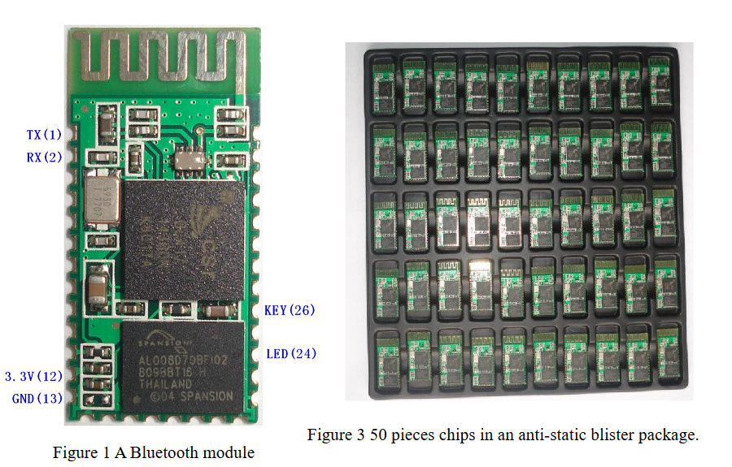

2. Feature

Wireless transceiver

Sensitivity (Bit error rate) can reach -80dBm.

The change range of output’s power: -4 - +6dBm.

Function description (perfect Bluetooth solution)

Has an EDR module; and the change range of modulation depth: 2Mbps - 3Mbps.

Has a build-in 2.4GHz antenna; user needn’t test antenna.

Has the external 8Mbit FLASH

Can work at the low voltage (3.1V~4.2V). The current in pairing is in the range of 30

～ 40mA. The current in communication is 8mA.

Standard HCI Port (UART or USB)

USB Protocol: Full Speed USB1.1, Compliant With 2.0

This module can be used in the SMD.

It’s made through RoHS process.

The board PIN is half hole size.

Has a 2.4GHz digital wireless transceiver.

Bases at CSR BC04 Bluetooth technology.

Has the function of adaptive frequency hopping.

Small (27mm×13mm×2mm)

Peripherals circuit is simple.

It’s at the Bluetooth class 2 power level.

Storage temperature range: -40°C-85°C work temperature range: -25°C- +75°C

Any wave inter Interference: 2.4MHz，the power of emitting: 3 dBm.

Bit error rate: 0. Only the signal decays at the transmission link, bit error may be produced. For example, when RS232 or TTL is being processed, some signals may decay.

Low power consumption

Has high-performance wireless transceiver system

Low Cost

Application fields:

Bluetooth Car Handsfree Device

Bluetooth GPS

Bluetooth PCMCIA, USB Dongle

Software

CSR

3．PINs description

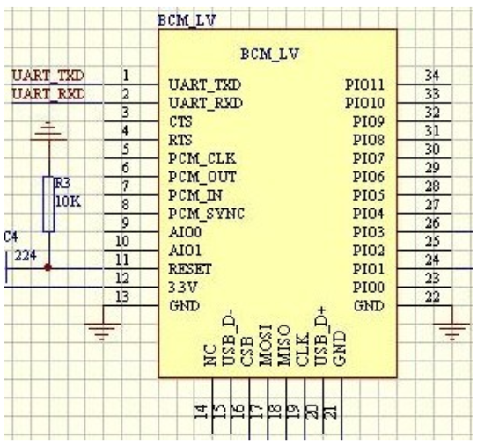

Figure 3 PIN configuration

The PINs at this block diagram is as same as the physical one.

|  |  |  |  |
| --- | --- | --- | --- |
| PIN Name | PIN # | Pad type | Description |
| GND | 13 21 22 | VSS | Ground pot |
| 1V8 | 14 | VDD | Integrated 1.8V (+) supply with. On-chip linear regulator output within 1.7-1.9V |
| VCC | 12 | 3.3 V |  |
| AIO0 | 9 | Bi-Directional | Programmable input/output line |
| AIO1 | 10 | Bi-Directional | Programmable input/output line |

Guangzhou HC Information Technology Co., Ltd.

www.wavesen.com

Phone: 020-84083341 Fax: 020-84332079 QQ:1043073574

Address: Room 527, No.13, Jiangong Road, Tianhe soft

ware park, Tianhe district, Guangzhou Post: 510660

Technology consultant:

support@wavesen.com

Business consultant:

sales@wavesen.com

Complaint and suggestion

:

sunbirdit@hotmail.com

PIO0 23

Bi-Directional

RX EN

Programmable input/output line,

control output for LNA(if fitted)

PIO1 24

Bi-Directional

TX EN

Programmable input/output line,

control output for PA(if fitted)

PIO2 25 Bi-Directional Programmable input/output line

PIO3 26 Bi-Directional Programmable input/output line

PIO4 27 Bi-Directional Programmable input/output line

PIO5 28 Bi-Directional Programmable input/output line

PIO6 29 Bi-Directional Programmable input/output line

CLK_REQ

PIO7 30 Bi-Directional Programmable input/output line

CLK_OUT

PIO8 31 Bi-Directional Programmable input/output line

PIO9 32 Bi-Directional Programmable input/output line

PIO10 33 Bi-Directional Programmable input/output line

PIO11 34 Bi-Directional Programmable input/output line

RESETB 11

CMOS Input with

weak intemal

pull-down

UART_RTS 4

CMOS output,

tri-stable with weak

internal pull-up

UART request to send, active low

UART_CTS 3

CMOS input with

weak internal

pull-down

UART clear to send, active low

UART_RX 2

CMOS input with

weak internal

pull-down

UART Data input

UART_TX 1

CMOS output,

Tri-stable with

weak internal

pull-up

UART Data output

SPI_MOSI 17

CMOS input with

weak internal

pull-down

Serial peripheral interface data input

SPI_CSB 16

CMOS input with

weak internal

Chip select for serial peripheral

interface, active low

Guangzhou HC Information Technology Co., Ltd.

www.wavesen.com

Phone: 020-84083341 Fax: 020-84332079 QQ:1043073574

Address: Room 527, No.13, Jiangong Road, Tianhe soft

ware park, Tianhe district, Guangzhou Post: 510660

Technology consultant:

support@wavesen.com

Business consultant:

sales@wavesen.com

Complaint and suggestion

:

sunbirdit@hotmail.com

pull-up

SPI_CLK 19

CMOS input with

weak internal

pull-down

Serial peripheral interface clock

SPI_MISO 18

CMOS input with

weak internal

pull-down

Serial peripheral interface data

Output

USB_- 15 Bi-Directional

USB_+ 20 Bi-Directional

1.8V

14

1.8V external power supply input

Default :

1.8V

internal powe

r supply.

PCM_CLK 5 Bi-Directional

PCM_OUT 6 CMOS output

PCM_IN 7 CMOS Input

PCM_SYNC 8 Bi-Directional

Guangzhou HC Information Technology Co., Ltd.

www.wavesen.com

Phone: 020-84083341 Fax: 020-84332079 QQ:1043073574

Address: Room 527, No.13, Jiangong Road, Tianhe soft

ware park, Tianhe district, Guangzhou Post: 510660

Technology consultant:

support@wavesen.com

Business consultant:

sales@wavesen.com

Complaint and suggestion

:

sunbirdit@hotmail.com

4. The parameters and mode of product

If you want more info

rmation, please visit

www.wavesen.com

.